First Metaphysical Church
April 2024Newsletter

Thanks goes out to Reverend Sherry Pickett
for the contribution of these awesome plants for Harmony Hall
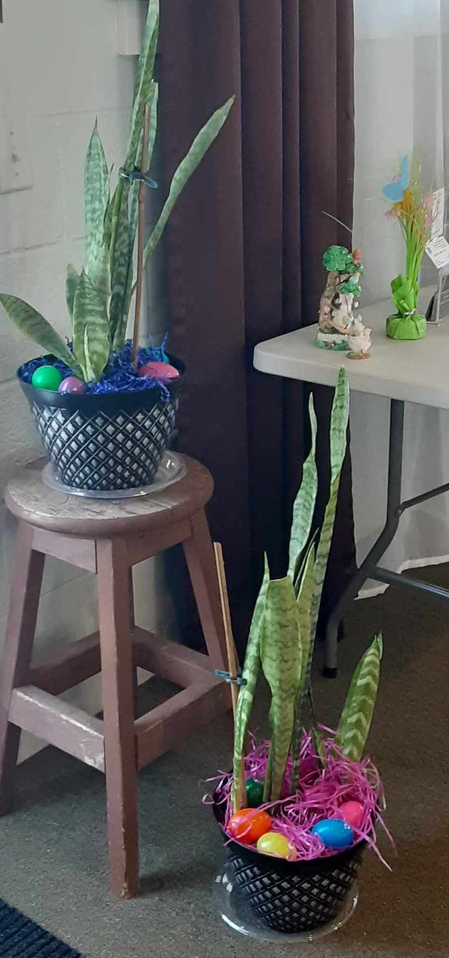
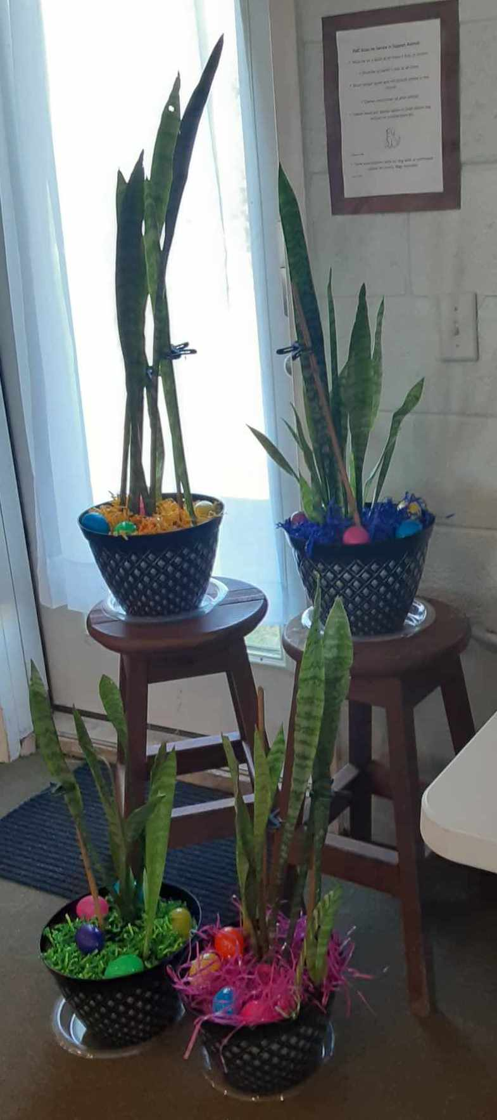
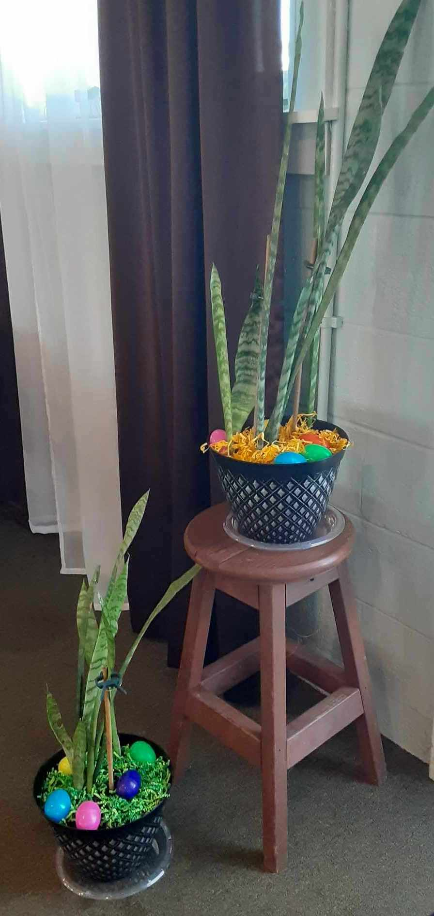

Dracaena trifasciata is a species of flowering plant in the family Asparagaceae, native to tropical West Africa from Nigeria east to the Congo. It is most commonly known as the snake plant, Saint George's sword, mother-in-law's tongue, and viper's bowstring hemp, among other names. This plant is often kept as a houseplant due to its non-demanding maintenance; they can survive with very little water and sun. In addition to being incredibly easy to grow, snake plants have a number of health benefits, including filtering indoor air, removing toxic pollutants, and are effective against allergies. These plants can also help by using its ability to convert carbon dioxide into oxygen at night. One other item, according to feng shui, these plants may help enhance the “energy” of a space. The Chinese love the snake plant for its ability to absorb negative energy!

2024
Healing Service 6pm Regular Service 6:30pm
Sunday | Monday |  | Tuesday | Wednesday | Thursday | Friday | Saturday
 | 1  April  Fools  Day | 2 |  | 3 | 4  Meditation  7-9pm | 5 | 6  Private Rental
7 | 8  New  Moon   | 9 |  | 10 | 11  Meditation  7-9pm | 12  Fair Setup  4-8pm | 13  Psychic Fair  11-6pm
14  Ministers  Meeting  3-5pm | 15 | 16 |  | 17  What is an  Empath?  6-8pm | 18  Meditation  7-9pm | 19 | 20  Introduction to Shamanic Journey  2-4pm  $33
21  Shamanic Journey  12-2pm  Board Meeting  3-5pm | 22  Earth  Day | 23  Full  Moon   |  | 24  What is an  Empath?  6-8pm | 25  Meditation  7-9pm | 26  Pagen Roundtable  7 pm | 27
28  Potluck 4pm  Drumming 5pm | 29 | 30 |  |  | April Correspondences  Stones: Diamond, moonstone  Animal: Falcon/hawk, wolf  Flower: Sweet pea, daisy  Ruling planet: Mars
 Meditation
Every Thursday, April 4, 11, 18, and 25, 2024 7:00 to 9pm
Our weekly meditation class is back! Every Thursday from 7:00 – 9 pm. The intention is to deepen our experience with the practice of meditation. Join us for a relaxing way to de-stress from daily pressures and commune with your spirit guides. Cost: Love Contribution.

 Psychic Fair
April 13, 2024 11am to 6pm
FMC is home to the longest continuing monthly psychic fair in SE Michigan! We have a number of excellent tarot readers, mediums, healers, and a variety of artisans with a wide assortment of handcrafted items including, jewelry, soaps, lotions and potions, incense, crystals and gemstones, and singing bowls. Cost: $5

 What is an Empath?
Wednesday, April 17, 24, May 1, 8, 15, 22, and 29
6-8pm

This seven (7) week class will teach people what it is to be an Empath. Are you an Empath and what are the traits that you have? You will also learn how to cope with being a highly sensitive person and how to set boundaries between you and others. Weekly dates are Wednesdays, 6pm to 8pm, April 17th, 24th, May 1st, 8th, 15th, 22nd and 29th. Class instructor is Reverend Bobbie-Jo MacLachlan.
Cost is $5 contribution.

 Introduction to Shamanic Journeying
Saturday, April 20, 2pm- 4pm
Shamanic journeying is a technique that involves entering an altered state of consciousness to explore the spirit world. All printed materials are provided and you will be able to join the ongoing Shamanic journeying monthly. Cost: $33.

 Shamanic Journeying
Sunday, April 21, 2024 12 noon to 2pm
Location at FMC. Bring the following: drums, rattles, sacred objects, comfortable shoes or slippers, and singing bowls. We plan to be in ceremony entire time. Cost: Love contribution.
 Board Meeting
Sunday April 21, 2024 3 to 5pm

All members are welcome to observe the working of our Board and share your ideas on how we can better serve you. Minutes from the Board of Directors meetings are available to all members of the Congregation and can be picked up at any of our Sunday services.
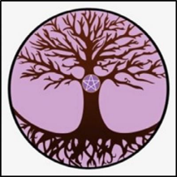 Pagan Roundtable North
April 26, 2024 7:00pm
We will be studying Comparative Pagan Religions, what they are and the paths
that each of them take. Everyone welcome.

MILES AND MILES OF GARAGE SALES ALONG
M-15 HERITAGE ROUTE
COME SEE US AT THE
FIRST METAPHYSICAL CHURCH
8267 E ATHERTON RD DAVISON, MI 48423
One mile west of M-15



MAY 4, 2024
11 AM-5 PM
CHURCH SOCIAL HALL

CASH AND CREDIT CARD ACCEPTED THAT DAY

Do you want to participate and sell your own collection of treasures? Rent an inside space for $15 (8 FT table provided) or an outside space 10x10 for $10 (bring your own table and chairs).

Donations can also be dropped off Thursday May 2nd and
Friday May 3rd.
10am to 4pm
Refreshments and Snacks available

Please contact Jack Mercer 810-919-0582 or Sherry Pickett 810-964-7535
Or fmc@firstmetaphysical.org

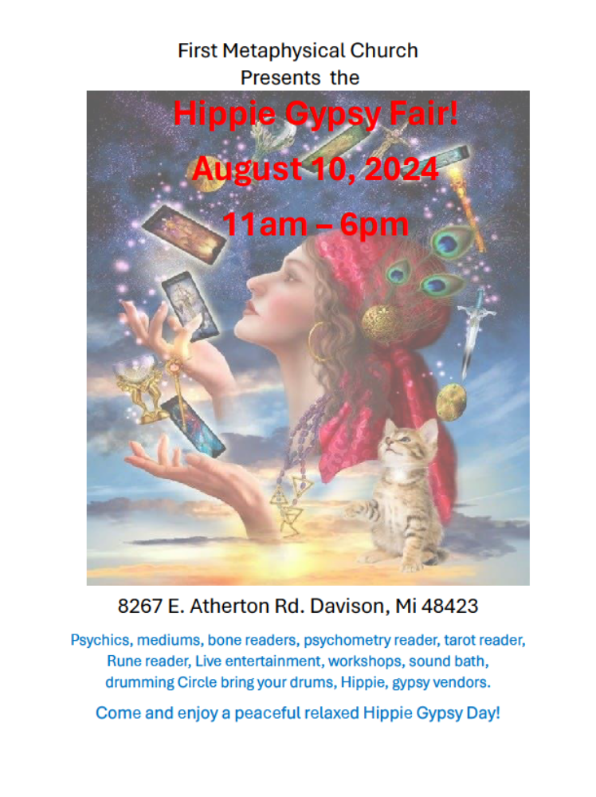
Please see Reverend Bobbi-Jo MacLachlan for information on reserving a vendor or reader spot.
810-880-9281
FMC Board of Directors of 2024

Head Minister…Reverend Heidi Phaneu FB or 810-444-2202
President…Reverend Sherry Pickett FB or 810-964-7535
Vice President…Ann Nedela F or 810-653-7082
Trustees…Mark Flowers 810-358-9144
Jon Torrey FB or 231-329-9805
Phil Joslin FB or 248-636-8138
Jack Mercer FB

Phone numbers for FMC Ministers
Head Minister Reverend Heidi Phaneuf 810-444-2202
Reverend Kelly Bailey 989-878-3081
Reverend Jeannie Genaw 810-407-0859
Reverend Jessica Guibord 248-514-0032
Reverend Nicky Highlen 248-240-1864
Reverend Cathy Jones 989-445-0398 (prefers texts only)
Reverend Linda Kinard 810-652-3554
Reverend Beverly LaJoie 989-325-0673
Reverend Connie Lundy 248-627-2841
Reverend Bobbie-jo MacLachlan 810-880-9281
Reverend Bonnie/Reverend Gary Neighorn 810-516-2050
Reverend Sherry Pickett 810-964-7535
Reverend Carol Richardson 810-630-1172
Reverend Bob Wahl 810-423-0759
Reverend Jim Walker 734-377-1652


April Birthdays at FMC
Ginger Guindon4-2
Erika (Gaia) Ratkov 4-2
Tamara Wilson4-3
Rev Anna Elston 4-3
Rev Cathy Jones 4-14
Shelley Beaulieu 4-14
Collette Weir 4-14
Rev Bonnie Neighorn 4-20

FIRST METAPHYSICAL CHURCH
8267 E ATHERTON ROAD
DAVISON, MI 48423
(810) 653-3291
www.firstmetaphysical.org
Facebook: First Metaphysical Church

We are an Inter-faith organization, and we honor the truth in all religions. We accept people of all faiths and invite everyone to join us in our spiritual journeys. It doesn't matter by what name you call your God or Goddess; it's what's in your heart that counts. Your own individual path to spiritual growth is always accepted in this church without judgment as long as you harm no one. We believe in the Divinity of each person and the sacredness of nature.
Harmony Hall rental: Seats 75 people
Please call for information: 810-653-3291

